#E4 Greenhouse Mivi Density Expt - summer 2011

#ANALYSES – take 2

Experimental design:

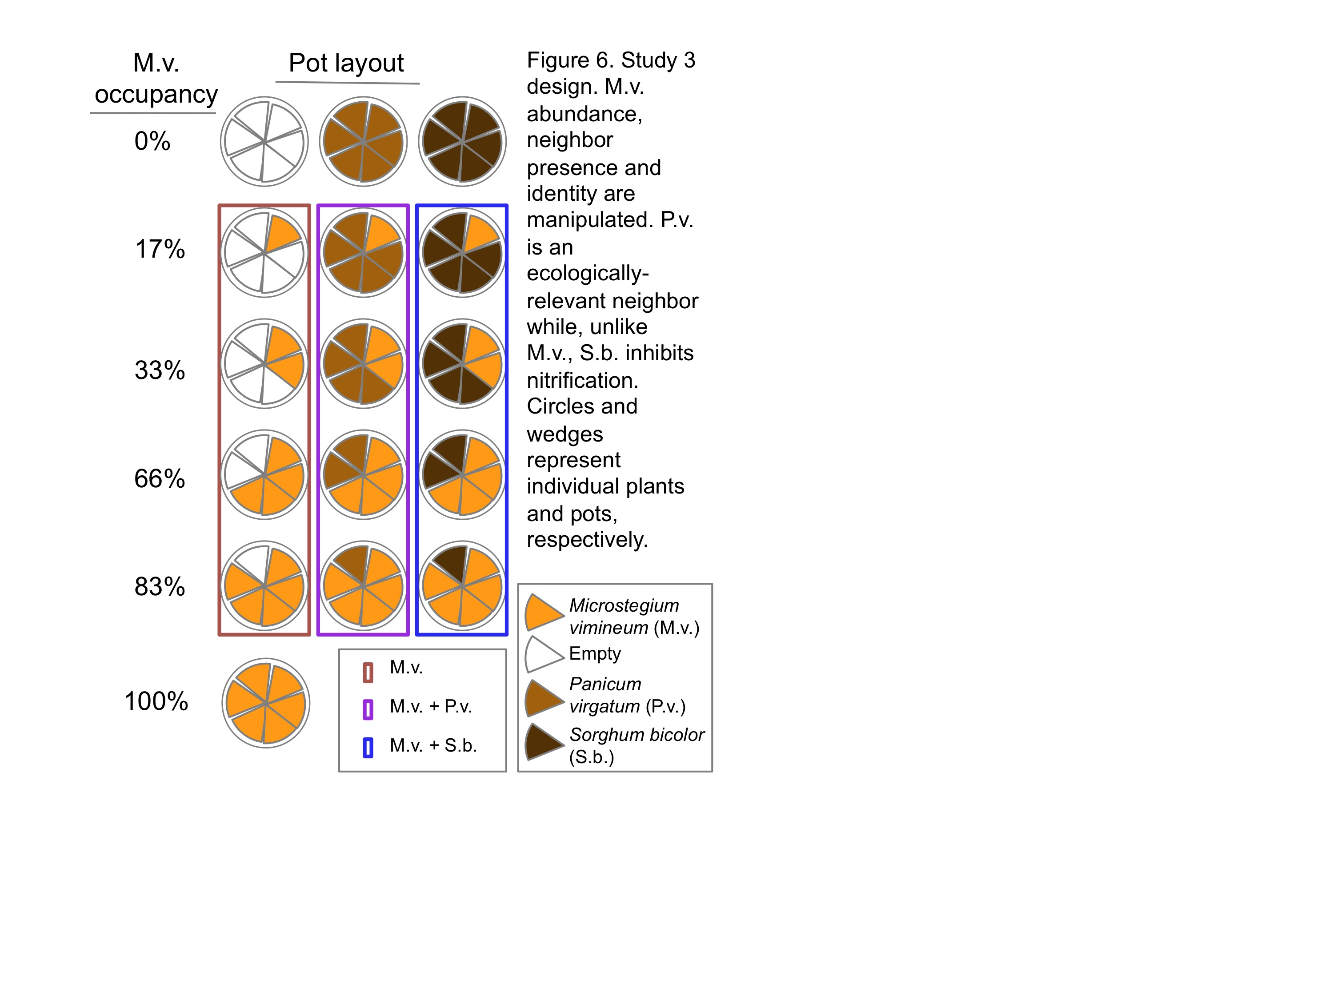

#Q0: Does the plant community monoculture treatment describe soil N pools and fluxes (as we have seen before)?

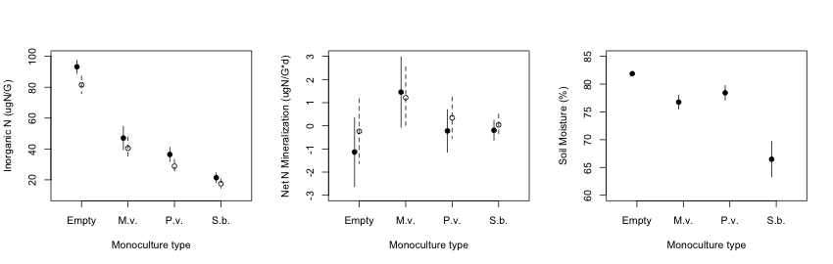

Legends: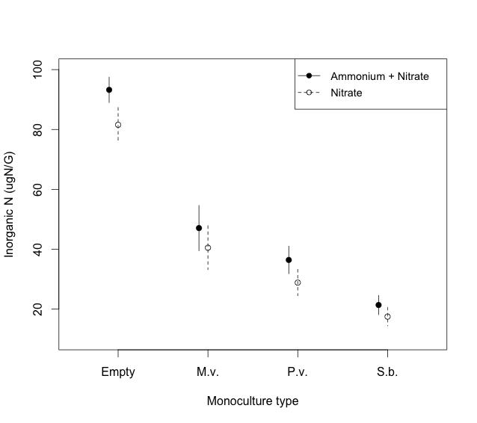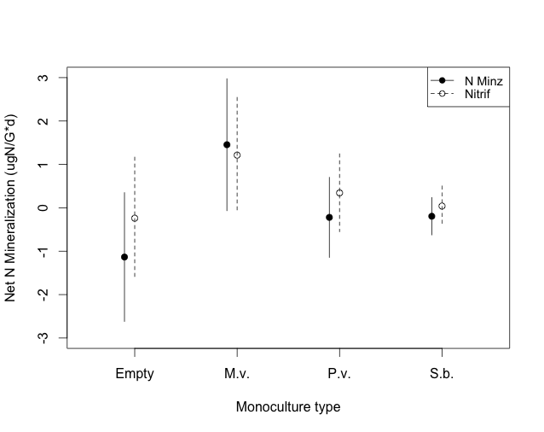

|  |  |  |  |  |  |  |
| --- | --- | --- | --- | --- | --- | --- |
| Table X. Study 3 summary of the influence of plant monoculture treatment (type: Empty, M.v., P.v., S.b.) on soil N pools, fluxes, and soil moisture. For all mixed effect models, type was a fixed effect and block was a random effect. Model details reports fixed effect coefficients and p-values, which were calculated with respect to the empty pot treatment level. | | | | | | |
| **Response** | **Fixed**  **effect** | **AIC** | **df** | **Model**  **details** | **Coef** | **p-value** |
| nodi | type | 344.42 | 27 | typeMivi | -41.06 | <0.01 |
| 27 | typePavi | -52.71 | <0.01 |
| 27 | typeSobi | -64.06 | <0.01 |
| totdi | type | 341.74 | 27 | typeMivi | -46.16 | <0.01 |
| 27 | typePavi | -56.81 | <0.01 |
| 27 | typeSobi | -71.86 | <0.01 |
| nitrifd | type | 212.49 | 27 | typeMivi | 1.45 | ns |
| 27 | typePavi | 0.58 | ns |
| 27 | typeSobi | 0.28 | ns |
| minzd | type | 222.98 | 27 | typeMivi | 2.59 | 0.07 |
| 27 | typePavi | 0.91 | ns |
| 27 | typeSobi | 0.94 | ns |
| soilmoi | type | 262.00 | 27 | typeMivi | -5.12 | 0.06 |
| 27 | typePavi | -3.44 | ns |
| 27 | typeSobi | -15.39 | <0.01 |

#Q1: Did the density treatment last until harvest?

|  |  |  |  |  |  |  |
| --- | --- | --- | --- | --- | --- | --- |
| Table X. Study 3 results of the influence of M.v. density treatment (percmiviind) on M.v. biomass (g) at harvest (mivi). In this mixed effect models, percmiviind was a fixed effect and block was a random effect. Model details reports fixed effect coefficients and p-values. | | | | | | |
| **Response** | **Fixed effect** | **AIC** | **df** | **Model details** | **Coef** | **p-value** |
| mivi | percmiviind | 262.72 | 27 | percmiviind | 0.21 | <0.01 |

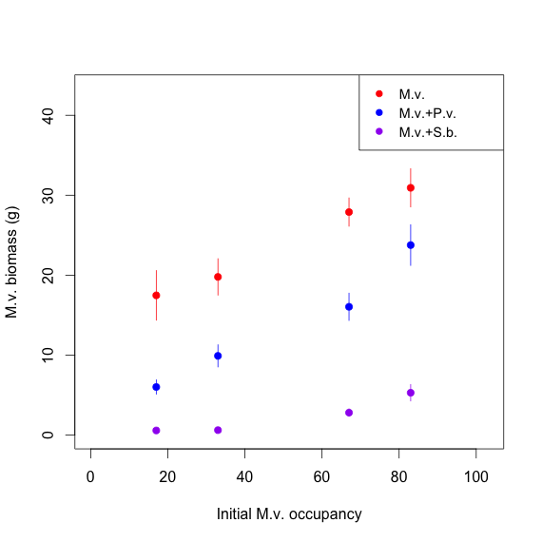

#Q2a: Does initial M.v. occupancy and neighbor treatment describe soil N pools and fluxes?

|  |  |  |  |  |  |  |  |
| --- | --- | --- | --- | --- | --- | --- | --- |
| Table X. Study 3 AIC model selection. Model families are shown that include initial M.v. occupancy (percmiviind: 17, 33, 67, 83%), competition treatment (comptrt: M.v., M.v.+P.v., or M.v.+S.b.) and their interactions for soil N pools, fluxes, and soil moisture. Block was included as a random effect. Model details reports fixed effect coefficients and p-values, which were calculated with respect to the empty pot treatment level. Models with the lowest AIC value are shaded in gray. | | | | | | | |
| **Response** | **Model** | **Fixed effects** | **df** | **AIC** | **Model**  **details** | **Coef** | **p-value** |
| nodi | 1 | percmiviind+comptrt+percmiviind*comptrt | 8 | 904.74 |  |  |  |
| 2 | percmiviind+comptrt | 6 | 900.85 |  |  |  |
| 3 | percmiviind | 4 | 924.75 |  |  |  |
| 4 | comptrt | 5 | 900.62 | comptrtP | -2.85 | ns |
| comptrtS | -11.44 | <0.01 |
| totdi | 1 | percmiviind+comptrt+percmiviind*comptrt | 8 | 928.86 |  |  |  |
| 2 | percmiviind+comptrt | 6 | 925.74 | percmiviind | 0.06 | 0.09 |
| comptrtP | -1.06 | ns |
| comptrtS | -12.89 | <0.01 |
| 3 | percmiviind | 4 | 953.67 |  |  |  |
| 4 | comptrt | 5 | 926.71 |  |  |  |
| nitrifd | 1 | percmiviind+comptrt+percmiviind*comptrt | 8 | 554.99 |  |  |  |
| 2 | percmiviind+comptrt | 6 | 553.8 |  |  |  |
| 3 | percmiviind | 4 | 557.57 |  |  |  |
| 4 | comptrt | 5 | 551.93 | comptrtP | 1.35 | 0.01 |
| comptrtS | 0.28 | ns |
| minzd | 1 | percmiviind+comptrt+percmiviind*comptrt | 8 | 545.44 |  |  |  |
| 2 | percmiviind+comptrt | 6 | 543.64 |  |  |  |
| 3 | percmiviind | 4 | 545.27 |  |  |  |
| 4 | comptrt | 5 | 541.7 | comptrtP | 1.13 | 0.02 |
| comptrtS | 0.34 | ns |
| soilmoi | 1 | percmiviind+comptrt+percmiviind*comptrt | 8 | 728.05 | percmiviind | -0.04 | ns |
| comptrtP | -1.24 | ns |
| comptrtS | -15.02 | <0.01 |
| percmiviind:  comptrtP | 0.03 | ns |
| percmiviind:  comptrtS | 0.15 | <0.01 |
| 2 | percmiviind+comptrt | 6 | 736.8 |  |  |  |
| 3 | percmiviind | 4 | 779.51 |  |  |  |
| 4 | comptrt | 5 | 735.83 |  |  |  |

#Q2b: Does final M.v. occupancy and neighbor treatment describe soil N pools and fluxes?

|  |  |  |  |  |  |  |  |
| --- | --- | --- | --- | --- | --- | --- | --- |
| Table X. Study 3 AIC model selection. Model families are shown that include final M.v. biomass (mivi), competition treatment (comptrt: M.v., M.v.+P.v., or M.v.+S.b.) and their interactions for soil N pools, fluxes, and soil moisture. Block was included as a random effect. Model details reports fixed effect coefficients and p-values, which were calculated with respect to the empty pot treatment level. Models with the lowest AIC value are shaded in gray. | | | | | | | |
| **Response** | **Model** | **Fixed effects** | **df** | **AIC** | **Model**  **details** | **Coef** | **p-value** |
| nodi | 1 | mivi+comptrt+mivi*comptrt | 8 | 904.51 |  |  |  |
| 2 | mivi+comptrt | 6 | 902.62 |  |  |  |
| 3 | mivi | 4 | 911.16 |  |  |  |
| 4 | comptrt | 5 | 900.62 | comptrtP | -2.85 | ns |
| comptrtS | -11.44 | <0.01 |
| totdi | 1 | mivi+comptrt+mivi*comptrt | 8 | 930.32 |  |  |  |
| 2 | mivi+comptrt | 6 | 928.71 |  |  |  |
| 3 | mivi | 4 | 941.29 |  |  |  |
| 4 | comptrt | 5 | 926.71 | comptrtP | -1.18 | ns |
| comptrtS | -13.01 | <0.01 |
| nitrifd | 1 | mivi+comptrt+mivi*comptrt | 8 | 556.45 |  |  |  |
| 2 | mivi+comptrt | 6 | 552.95 |  |  |  |
| 3 | mivi | 4 | 556.81 |  |  |  |
| 4 | comptrt | 5 | 551.93 | comptrtP | 1.35 | 0.01 |
| comptrtS | 0.28 | ns |
| minzd | 1 | mivi+comptrt+mivi*comptrt | 8 | 546.47 |  |  |  |
| 2 | mivi+comptrt | 6 | 542.86 |  |  |  |
| 3 | mivi | 4 | 544.27 |  |  |  |
| 4 | comptrt | 5 | 541.7 | comptrtP | 1.13 | 0.02 |
| comptrtS | 0.34 | ns |
| soilmoi | 1 | mivi+comptrt+mivi*comptrt | 8 | 734.03 | percmiviind | -0.11 | ns |
| comptrtP | -1.78 | ns |
| comptrtS | -12.06 | <0.01 |
| percmiviind:  comptrtP | 0.06 | ns |
| percmiviind:  comptrtS | 0.89 | <0.01 |
| 2 | mivi+comptrt | 6 | 737.46 |  |  |  |
| 3 | mivi | 4 | 764.15 |  |  |  |
| 4 | comptrt | 5 | 735.83 |  |  |  |

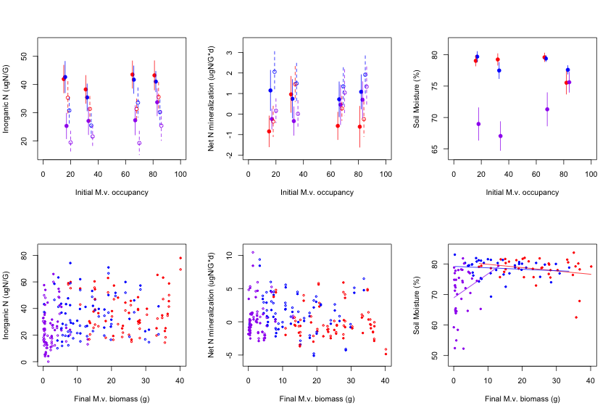

Legends: